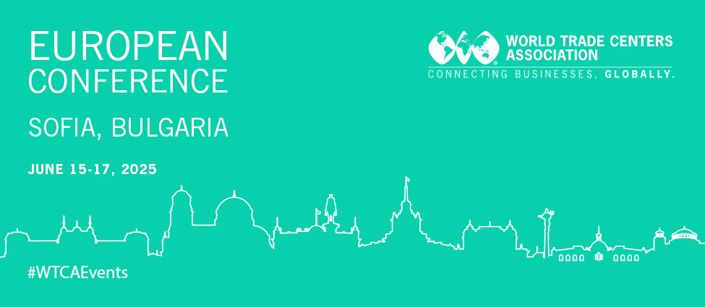

**Agenda**

[Monday, June 16, 2025](https://wtca.swoogo.com/wtcaeurope2025/agenda#w_65798045_tab_2)

BCCI, 1st floor, Hall A

|  |  |  |
| --- | --- | --- |
| 8:30 AM - 9:00 AM | Networking Breakfast |  |
| 9:00 AM - 9:30 AM | Welcoming Words | [Peter Dilov, Republic of Bulgaria](https://wtca.swoogo.com/WTCAEurope2025/speaker/1719483/petar-dilov) [Tsvetan Simeonov, Bulgarian Chamber of Commerce and Industry & GS1 Bulgaria](https://wtca.swoogo.com/WTCAEurope2025/speaker/1719494/tsvetan-simeonov) |
| 9:30 AM - 9:40 AM | Attendees’ introductions |  |
| 9:40 AM - 10:00 AM | Bulgaria as an investment destination | [Mila Nenova, Invest Bulgaria Agency](https://wtca.swoogo.com/WTCAEurope2025/speaker/1719491/mila-nenova) [Viktor Gusev, Sofia Investment Agency](https://wtca.swoogo.com/WTCAEurope2025/speaker/1738622/viktor-gusev) |
| 10:00 AM - 10:30 AM | Overcoming current and future sectorial challenges (automotive & energy) | [Lyubomir Stanislavov, Automotive Cluster Bulgaria](https://wtca.swoogo.com/WTCAEurope2025/speaker/1719488/lyubomir-stanislavov) [Veselin Todorov, Solar Academy Bulgaria](https://wtca.swoogo.com/WTCAEurope2025/speaker/1719493/veselin-todorov) |
| 10:30 AM - 10:35 AM | Group Photo |  |
| 10:35 AM - 11:00 AM | Networking Coffee Break |  |
| 11:00 AM - 11:45 AM | Developing value-adding common denominators for WTC Businesses | [Freerk Faber, World Trade Center Twente](https://wtca.swoogo.com/WTCAEurope2025/speaker/1720002/freerk-faber) [Antony Georgakis, WTC Cyprus](https://wtca.swoogo.com/WTCAEurope2025/speaker/1720068/antony-georgakis) |
| 11:45 AM - 12:15 PM | Borderless Artificial Intelligence | [Kristina Eskenazi, Artificial Intelligence Cluster Bulgaria](https://wtca.swoogo.com/WTCAEurope2025/speaker/1719789/kristina-eskenazi) |
| 12:15 PM - 12:45 PM | Transfer from WTC Sofia (AF) to WTC Sofia |  |
| 12:45 PM - 2:00 PM | Networking Lunch |  |
| 2:00 PM - 2:45 PM | Tour of the WTC Sofia Facilities |  |
| 2:45 PM - 3:45 PM | Developing value adding common denominators for WTC businesses | [Freerk Faber, World Trade Center Twente](https://wtca.swoogo.com/WTCAEurope2025/speaker/1720002/freerk-faber) [Antony Georgakis, WTC Cyprus](https://wtca.swoogo.com/WTCAEurope2025/speaker/1720068/antony-georgakis) |
| 3:45 PM - 4:00 PM | Transfer from WTC Sofia to Sofia Tech Park |  |
| 4:00 PM - 5:00 PM | Discovery of the Sofia Tech Park |  |
| 5:00 PM - 5:30 PM | Transfer from Sofia Tech Park to Sofia Balkan Palace |  |
| 5:30 PM - 6:00 PM | Free time |  |
| 6:00 PM - 7:30 PM | Wine Tasting Speed Networking |  |
| 7:30 PM - 8:00 PM | Transfer from Sofia Balkan Palace to Vitosha Mountain |  |
| 8:30 PM - 10:30 PM | Traditional Bulgarian Dinner  Restaurant VODENITSATA |  |

[Tuesday, June 17, 2025](https://wtca.swoogo.com/wtcaeurope2025/agenda#w_65798045_tab_3)

BCCI, 1st floor, Hall A

|  |  |  |  |
| --- | --- | --- | --- |
| 8:30 AM - 9:00 AM | Networking Breakfast |  |  |
| 9:00 AM - 9:45 AM | Opportunities in Europe for Regional Integration and Economic Development | [Krassen Stanchev, Institute for Market Economics](https://wtca.swoogo.com/WTCAEurope2025/speaker/1719492/krassen-stanchev) |  |
| 9:45 AM - 10:30 AM | Role of the European WTC Businesses in Regional Integration and Economic Development | [Nicholas Beaty, WTC Rennes Bretagne](https://wtca.swoogo.com/WTCAEurope2025/speaker/1719999/nicholas-beaty) [Patricia Moinard, WTC METZ-SAARBRÜCKEN](https://wtca.swoogo.com/WTCAEurope2025/speaker/1720070/patricia-moinard) |  |
| 10:30 AM - 11:00 AM | Networking Coffee Break |  |  |
| 11:00 AM - 11:30 AM | WTCA Update | [Anaïs Jan, World Trade Centers Association](https://wtca.swoogo.com/WTCAEurope2025/speaker/1720355/ana%C3%AFs-jan) [Sharon Aguayo, World Trade Centers Association](https://wtca.swoogo.com/WTCAEurope2025/speaker/1719480/sharon-aguayo) |  |
| 11:30 AM - 11:45 AM | Flash Sessions |  |  |
| 11:45 AM - 12:45 PM | From Multi-Purpose Building to Destination: Real Estate Uses of WTC Buildings | [Carles Anglada, World Trade Center Barcelona](https://wtca.swoogo.com/WTCAEurope2025/speaker/1720360/carles-anglada) [Ed Allison-Wright, World Trade Center Gibraltar](https://wtca.swoogo.com/WTCAEurope2025/speaker/1720365/ed-allison-wright) |  |
| 12:45 PM - 12:55 PM | Passing of the Baton: Your 2026 Europe Conference Host |  |  |
| 12:55 PM - 1:00 PM | Closing Words |  |  |
| 1:00 PM - 2:30 PM | Networking Lunch at TSUM | [Ahmed Nasr, Antika World](https://wtca.swoogo.com/WTCAEurope2025/speaker/1719540/ahmed-nasr) |  |
| 2:30 PM - 5:00 PM | Discover Sofia |  |  |